**Discrete Mathematical Structures**

**Week-1 (Set Theory)**

**Long Descriptive Questions**

1. In a competition, a school awarded medals in different categories. 36 medals in dance, 12 medals in dramatics and 18 medals in music. If these medals went to a total of 45 persons and only 4 persons got medals in all the three categories, how many received medals in exactly two of these categories?

**SOLUTION**

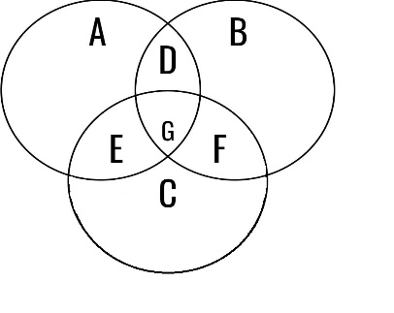let n(A): medals awarded for dance =36

n(B): medals awarded for dramatics =12

n(C): medals awarded for music =18

n(A Ս B Ս C) =45

n(A Ո B Ո C) =4

A+D+G+E =36 →①

B+D+G+F =12 →②

C+F+G+E =18 →③

G =4 →④

A+B+C+D+E+F+G =45 →⑤

From ① and ④ A+D+E =32

From ② and ④ B+D+F =8

From ③ and ④ C+F+E =14

A+B+C+2(D+E+F) =54

From ⑤ and ④

A+B+C+(D+E+F) =41

→ D+E+F =13

No of medals awarded in exactly two categories =13

2,Which of the following is an equivalence relation?

a) The relation R on Z defined by aRb if a 2 − b 2 ≤ 7.

b) The relation R on Z defined by aRb if 2a + 5b ≡ 0 (mod 7).

c) The relation R on Z defined by aRb if a + b ≡ 0 (mod 5).

d) The relation R on Z defined by aRb if a 2 + b 2 = 0.

To be an equivalence relation, a relation on a set must satisfy three properties:

**Reflexive:** For all a in the set, aRa.

**Symmetric:** For all a, b in the set, if aRb, then bRa.

**Transitive:** For all a, b, c in the set, if aRb and bRc, then aRc.

* **The relation R on Z defined by aRb if a^2 - b^2 ≤ 7**. This relation is not reflexive because a^2 - a^2 = 0, which is not less than or equal to 7 for all integers a. Therefore, it fails the reflexivity property and is not an equivalence relation
* **The relation R on Z defined by aRb if 2a + 5b = 0 (mod 7)** is not an equivalence relation because it is not transitive. For example, let a = 1, b = 5, and c = 2. Then, aRb because 2(1) + 5(5) = 27 ≡ 0 (mod 7) and bRc because 2(5) + 5(2) = 20 ≡ 0 (mod 7). However, aRc is false because 2(1) + 5(2) = 12 ≢ 0 (mod 7)
* **The relation R on Z defined by aRb if a + b = 0 (mod 5)** is an equivalence relation because it satisfies all three properties.

**Reflexive:** For any integer a, a + a = 2a ≡ 0 (mod 5), so aRa.

**Symmetric:** If aRb, then a + b ≡ 0 (mod 5), which implies b + a ≡ 0 (mod 5), so bRa.

**Transitive:** If aRb and bRc, then a + b ≡ 0 (mod 5) and b + c ≡ 0 (mod 5), which implies a + c = (a + b) + (b + c) ≡ 0 + 0 = 0 (mod 5), so aRc

* **The relation R on Z defined by aRb if a^2 + b^2 = 0** is an equivalence relation because it satisfies all three properties.

**Reflexive:** For any integer a, a^2 + a^2 = 2a^2 ≠ 0 unless a = 0, so aRa holds only for a = 0.

**Symmetric:** If aRb, then a^2 + b^2 = 0, which implies b^2 + a^2 = 0, so bRa.

**Transitive:** If aRb and bRc, then a^2 + b^2 = b^2 + c^2 = 0, which implies a^2 + c^2 = (a^2 + b^2) + (b^2 + c^2) = 0 + 0 = 0, so aRc.

Therefore, the equivalence relations are (c) and (d)